-EDS
UNIT-I
Assignment-I
- Draw the structure of operating system and explain the role of kernel shell and system calls
- What is meant by CPU Scheduling and discuss about FCFS ,SJF with suitable examples.
- Discuss about RoundRobin algorithm with the suitable examples.

Draw the structure of Operating System and explain the role of Kernel, Shell and System Calls
Introduction
An Operating System (OS) is a program that acts as an intermediary between the user and computer hardware. It provides an environment for executing programs, manages hardware resources, and makes the computer convenient and efficient to use.

Structure of Operating System
A simple structure of an operating system can be represented as:
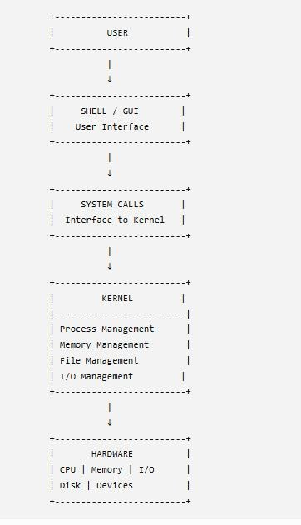

The OS structure separates user-level operations from core hardware management. The shell provides the user interface, system calls provide the interface to the kernel, and the kernel manages the actual hardware resources.

Shell
The Shell is the outermost user-interface layer of the operating system.

Functions of Shell
  - It accepts commands from the user.
  - It interprets the commands.
  - It translates user commands into operations that the OS can perform.
  - It can execute commands directly or invoke separate system programs.
  - It provides a command-line interface to interact with the OS.
For example, in Linux/Unix, shells such as bash, csh and tcsh are available.

Example:
User enters:
↓ Shell
↓
requests OS operation
↓ Kernel
↓ displays files

Kernel
The Kernel is the core component of the operating system. It runs continuously and directly manages system resources.

Major Functions of Kernel
- Process Management
  - Allocates CPU time to processes.
  - Creates and terminates processes.
  - Supports inter-process communication.

Memory Management
  - Keeps track of memory usage.

  - Allocates memory to processes.
  - Deallocates memory when it is no longer required.

File and Storage Management
  - Manages files and directories.
  - Controls access permissions.
  - Maps logical files to physical storage.

I/O Management
  - Manages input/output devices.
  - Uses device drivers.
  - Provides buffering and caching.
Thus, the kernel acts as both a resource allocator and a control program.

System Calls
A system call is the interface through which a user program or shell requests a service from the operating system kernel.
User programs cannot directly access privileged hardware resources. Therefore, they use system calls to request services from the kernel.

Main Types of System Calls
Type Examples Purpose
File management open(), read(), write(), close() Manage files Process control fork(), exec(), wait(), exit() Manage processes Memory management brk(), mmap(), munmap() Manage memory
IPC pipe(), socket(), shmget() Process communication Device management ReadConsole(), WriteConsole() Manage devices

User Mode and Kernel Mode
Modern operating systems use dual-mode execution for protection:
- User Mode: Applications and shells execute with restricted privileges.
- Kernel Mode: The kernel executes with access to privileged hardware resources.
When a system call is made, control is transferred from user mode to kernel mode so that the requested operation can be safely performed.

Conclusion

The Shell provides the interface to the user, System Calls provide the communication interface with the kernel, and the Kernel manages CPU, memory, files and I/O devices. Together, they form the fundamental structure through which users interact with computer hardware.

What is meant by CPU Scheduling? Discuss FCFS and SJF with suitable examples. Introduction
In a multiprogramming system, several processes may reside in main memory at the same time. When one process waits for I/O, the operating system can assign the CPU to another ready process.
The process of selecting a process from the ready queue and allocating the CPU to it is called CPU Scheduling. The selection is performed by the short-term scheduler or CPU scheduler.

Objectives of CPU Scheduling
A good scheduling algorithm aims to:
  - Maximize CPU utilization
  - Maximize throughput
  - Minimize turnaround time
  - Minimize waiting time
  - Minimize response time

Turnaround Time:

Waiting Time:

Where:
  - AT = Arrival Time
  - BT = Burst Time
  - CT = Completion Time
  - TAT = Turnaround Time
  - WT = Waiting Time

First-Come, First-Served (FCFS)
𝐴 = − 𝐴

= 𝐴 −

FCFS is the simplest CPU scheduling algorithm. The process that arrives first in the ready queue gets the CPU first.
It follows the FIFO (First-In, First-Out) principle.

Characteristics
  - Type: Non-preemptive
  - Scheduling rule: First process to arrive executes first
  - Data structure: FIFO queue
  - Once a process gets the CPU, it continues until completion or an I/O request.

Example
Consider the following processes: Process Arrival Time Burst Time

P1 | 0 | 5
P2 | 1 | 3
P3 | 2 | 8
P4 | 3 | 6

Step 1: Execution Order
According to arrival time:
P1 → P2 → P3 → P4

Step 2: Gantt Chart
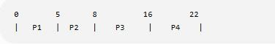

Step 3: Calculations
Process AT BT CT TAT = CT−AT WT = TAT−BT

P1 | 0 | 5 | 5 5 | 0
P2 | 1 | 3 | 8 7 | 4
P3 | 2 | 8 | 16 14 | 6
P4 | 3 | 6 | 22 19 | 13

Therefore,

𝐴𝑣𝑟𝑔 = 0 + 4 + 6 + 13 = 23 =
5.75 𝑠

4 4
𝐴𝑣𝑟𝑔 𝐴 = 5 + 7 + 14 + 19 = 45 =
11.25 𝑠
4 4
These are the values given in your study material.

Advantages of FCFS

- Very simple and easy to implement.
- Uses a simple FIFO queue.
- Fair according to arrival order.
- No starvation due to priority.

Disadvantage
The major disadvantage is the Convoy Effect. A long CPU-bound process can make several shorter processes wait for a long time, resulting in poor CPU and I/O utilization.

Shortest-Job-First (SJF)
Shortest-Job-First (SJF) is a CPU scheduling algorithm in which the process having the smallest CPU burst time is selected for execution next.
If two processes have the same burst time, the process that arrived earlier is selected. SJF is designed to minimize average waiting time.

Characteristics
  - Type: Non-preemptive
  - Selection criterion: Shortest CPU burst
  - Goal: Minimize average waiting time
  - Ready queue: Processes are considered according to burst time.

Example
Use the same processes:
Process Arrival Time Burst Time

P1 | 0 | 5
P2 | 1 | 3
P3 | 2 | 8
P4 | 3 | 6

Step 1: Execution Order
At time 0, only P1 has arrived, so P1 executes first. After P1 finishes at time 5:
  - P2 → BT = 3
  - P3 → BT = 8
  - P4 → BT = 6

Therefore P2 is selected.
After P2 finishes, P4 has the shortest burst among the remaining processes. Hence:
P1 → P2 → P4 → P3

Step 2: Gantt Chart
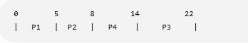

Step 3: Calculation
Process AT BT CT TAT WT

P1 | 0 | 5 | 5 5 | 0
P2 | 1 | 3 | 8 7 | 4
P4 | 3 | 6 | 14 11 | 5
P3 | 2 | 8 | 22 20 | 12
𝐴𝑣𝑟𝑔 = 0 + 4 + 5 + 12 = 21 =
5.25 𝑠

4 4
𝐴𝑣𝑟𝑔 𝐴 = 5 + 7 + 11 + 20 = 43 =
10.75 𝑠
4 4

Advantages of SJF
- Minimizes average waiting time.
- Provides better turnaround time compared with FCFS in many cases.
- Short jobs are completed quickly.

Disadvantages of SJF
- The exact CPU burst time must be known or estimated.
- Long processes may suffer from starvation if short processes continuously arrive.

FCFS vs SJF
Feature FCFS SJF
Full form First-Come, First-Served Shortest-Job-First
Type Non-preemptive Non-preemptive
Selection Arrival order Shortest burst
Principle FIFO Shortest job first
Average WT in example 5.75 ms 5.25 ms Main problem Convoy effect Starvation Conclusion
CPU scheduling is essential for efficient CPU utilization. FCFS is simple and fair according to
arrival order, while SJF generally provides lower average waiting time by executing shorter processes first.

Discuss Round Robin Algorithm with a suitable example. Introduction
Round Robin (RR) is a preemptive CPU scheduling algorithm mainly designed for time-sharing and interactive systems.
In Round Robin scheduling, each process receives the CPU for a fixed amount of time called the Time Quantum (TQ) or Time Slice. If the process does not finish within the time quantum, it is preempted and placed at the end of the ready queue. The CPU is then assigned to the next process.

Working
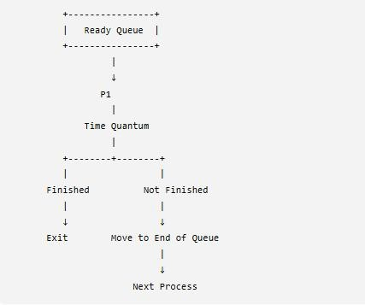

Characteristics of Round Robin
- Type: Preemptive
- Scheduling rule: FIFO with fixed time quantum
- Data structure: Circular queue
- Fairness: Every process receives an equal CPU time slice.
- Suitable for: Time-sharing and interactive systems.

Time Quantum
The Time Quantum is the maximum amount of CPU time allocated to a process before it is preempted.
For the following example:
𝑇 = 2 𝑠
Example Consider:
Process Arrival Time Burst Time

P1 | 0 | 5
P2 | 1 | 3
P3 | 2 | 8
P4 | 3 | 6
Time Quantum = 2 ms

Step 1: Execution
The processes are executed in circular order, with each process receiving at most 2 ms at a time.
The execution sequence is:
P1 → P2 → P3 → P1 → P4 → P2 → P3 → P1 → P4 → P3 → P4 → P3

Step 2: Gantt Chart
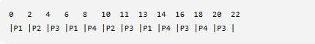
Notice that a process that does not complete in its time quantum goes to the end of the ready queue.

Step 3: Calculations

Process AT BT CT TAT = CT−AT WT = TAT−BT

P1 | 0 | 5 | 14 14 | 9
P2 | 1 | 3 | 11 10 | 7
P3 | 2 | 8 | 22 20 | 12
P4 | 3 | 6 | 20 17 | 11

Therefore,

𝐴𝑣𝑟𝑔 = 9 + 7 + 12 + 11 = 39 =
9.75 𝑠

4 4
𝐴𝑣𝑟𝑔 𝐴 = 14 + 10 + 20 + 17 = 61 =
15.25 𝑠

4 4

Advantages of Round Robin
- Fairness: Every process gets a chance to execute.
- No starvation: A ready process eventually gets CPU time.
- Good response time: Suitable for interactive applications.
- Simple implementation: Uses a circular ready queue.
- Suitable for time-sharing systems.

Disadvantages of Round Robin
- Performance depends heavily on the time quantum.
- Very small time quantum causes many context switches.
- Very large time quantum makes Round Robin behave similarly to FCFS.
- Average waiting and turnaround times can be higher than SJF in some workloads.

